Project Design Phase-II
Data Flow Diagram & User Stories

Date | 20 February 2026
Team ID | LTVIP2026TMIDS73549
Project Name | Streamlining Ticket Assignment for Efficient Support Operations
Maximum Marks | 4 Marks

Data Flow Diagrams:
A Data Flow Diagram (DFD) is a traditional visual representation of the information flows within a system. A neat and clear DFD can depict the right amount of the system requirement graphically. It shows how data enters and leaves the system, what changes the information, and where data is stored.

Example: (Simplified)
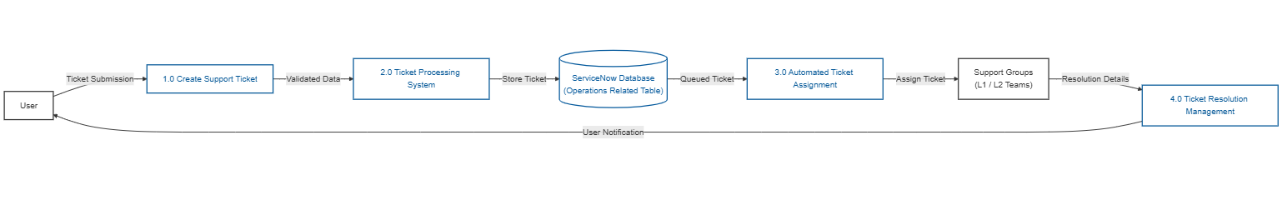

Data Flow Diagram – ServiceNow Operations Ticket Management System
The Data Flow Diagram (DFD) represents the overall flow of information within the ServiceNow Operations Ticket Management System. The system enables users to raise operational support tickets, which are processed and automatically assigned to appropriate support teams.
Initially, the user submits a support request through the ServiceNow portal. The ticket information is validated and processed by the ticket processing system. The validated ticket data is then stored in the ServiceNow database under the Operations Related table.
Based on the issue type selected by the user, the automated ticket assignment mechanism routes the ticket to the appropriate support group such as Level-1 or Level-2 Support Team. The assigned support team analyzes and resolves the issue and updates the ticket status accordingly.
Finally, resolution details and notifications are sent back to the user, ensuring efficient ticket handling and improved operational support management
User Stories
Use the below template to list all the user stories for the product.
User Type | Functional Requirement | User Story No | User Story | Acceptance Criteria | Priority | Release
System User | Ticket Creation | USN-1 | As a user, I want to create an operations support ticket so that my issue can be resolved. | Ticket is successfully created and stored in the system. | High | Sprint-1
System User | Issue Selection | USN-2 | As a user, I want to select issue type while creating a ticket. | Selected issue type is saved correctly. | High | Sprint-1
System User | Ticket Tracking | USN-3 | As a user, I want to view ticket status updates. | User can view updated ticket status. | Medium | Sprint-1
System User | Notification | USN-4 | As a user, I want to receive notification after ticket resolution. | Notification sent after resolution. | Medium | Sprint-1
Support Agent | Ticket Assignment | USN-5 | As a support agent, I want tickets to be automatically assigned to my group. | Ticket appears in assigned support group queue. | High | Sprint-1
Support Agent | Ticket Handling | USN-6 | As a support agent, I want to analyze assigned tickets. | Agent can access and process assigned tickets. | High | Sprint-1
Support Agent | Ticket Resolution | USN-7 | As a support agent, I want to update resolution details. | Ticket status updated successfully. | High | Sprint-1
Administrator | User Management | USN-8 | As an administrator, I want to manage users and roles. | Users and roles configured properly. | High | Sprint-1
Administrator | Access Control | USN-9 | As an administrator, I want to control table access permissions. | Authorized users only access records. | High | Sprint-1
Administrator | Flow Automation | USN-10 | As an administrator, I want to configure automated ticket routing flows. | Flow executes and assigns tickets automatically. | High | Sprint-1

